NAME: Aanand S  
CLASS:XII  
SCHOOL: Geethanjali Vidyalaya  
ACADEMIC YEAR: 2022-23

Computer report

Hotel Management

**CERTIFICATE**

**GEETHANJALI VIDYALAYA**

This is to certify that the following is a bonafide

record of the physics project work done by

Aanand Sanjenbam of Geethanjali Vidyalaya,

under the guidance of Mrs. M Chandrakala

(Subject Teacher), Board of Secondary

Education (CBSE) during the academic year

2022-23

EXTERNAL EXAMINER INTERNAL EXAMINER

INSTITUTION STAMP

**ACKNOWLEDGEMENT**

This project would not have been possible without proper guidance and support of Mrs. Seena, my Computer teacher. I am highly indebted to her for sharing her indispensable time and knowledge to make this project a success.

I would also like to express my gratitude towards the school management and The Principal for providing me with best of the facilities and environment and giving such wonderful opportunities to shine.

Finally, I want to thank my classmates who have willingly helped me in every possible manner.

**INDEX**

|  |  |  |
| --- | --- | --- |
| **S No.** | **CONTENTS** | **Page No.** |
| **1.** | INTRODUCTION | 5 |
| **2.** | SYSTEM REQUIREMENTS | 7 |
| **3.** | SOURCE CODE | 8 |
| **4.** | OUTPUT | 12 |
| **5.** | REFERNCES | 15 |

INTRODUCTION

# Title of the project:

Hotel Management System

## Prologue:

The main objective of this project is to provide the user an interface to book a hotel reservation. The program deals with storing the data of all hotel rooms.

The purpose of this project is the create an application program interface for management to access and update attributes of hotel rooms

The program also stores the details of any guests occupying a room in a database table.

# Team Members:

* Aanand Sanjenbam
* Abhinav Singh
* Mann

## Team details:

* The project “**Hotel Management System**” has been designed and developed by the 3 mentioned individuals. The various components of the project were shared between the members.

# Limitations:

* None

**SYSTEM REQUIREMENTS**

# Recommended system requirements:

* Processor: Intel Core i3
* Disk Space: 2 to 4 GB
* OS: Windows 10
* Python version: 3.x.x
* MYSQL Command line client: 5.5 or higher

# Minimum system requirements:

* Processor: Intel Atom or Intel i3
* Disk Space: 1 GB
* OS: Windows 7
* Python version: 2.7.x

# Prerequisites before running the code:

* Python must be installed and, in the system’s PATH
* MYSQL command line client is installed

**SOURCE CODE**

1. **main.py**

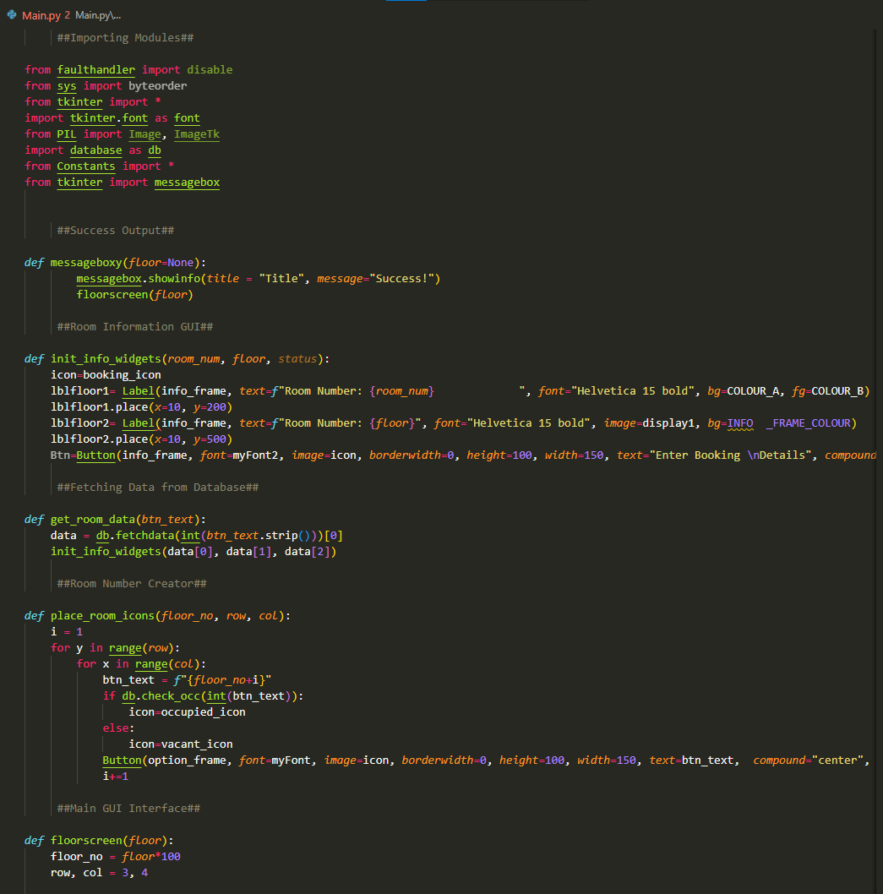

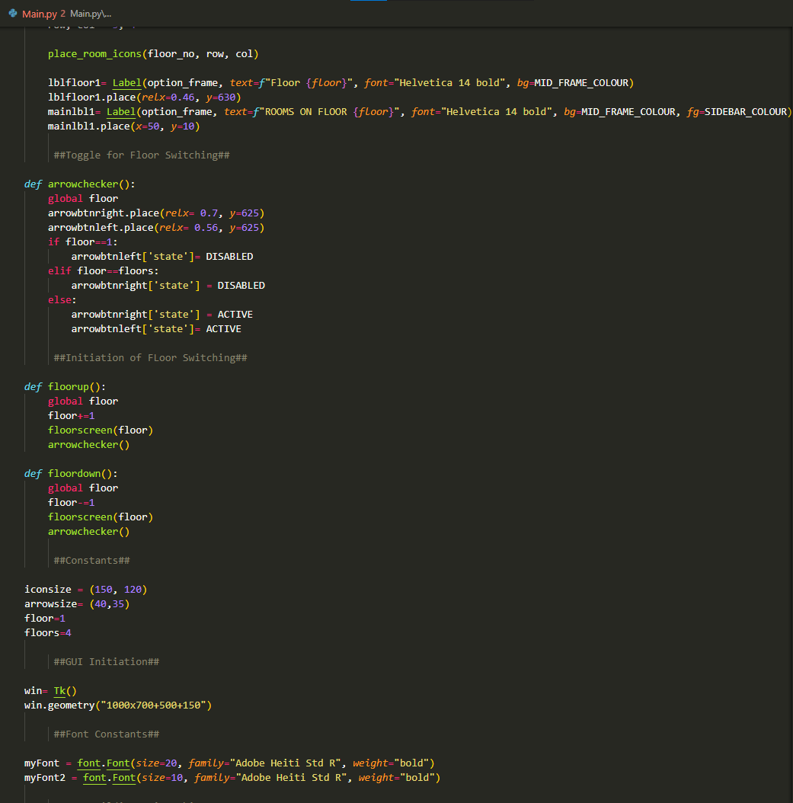

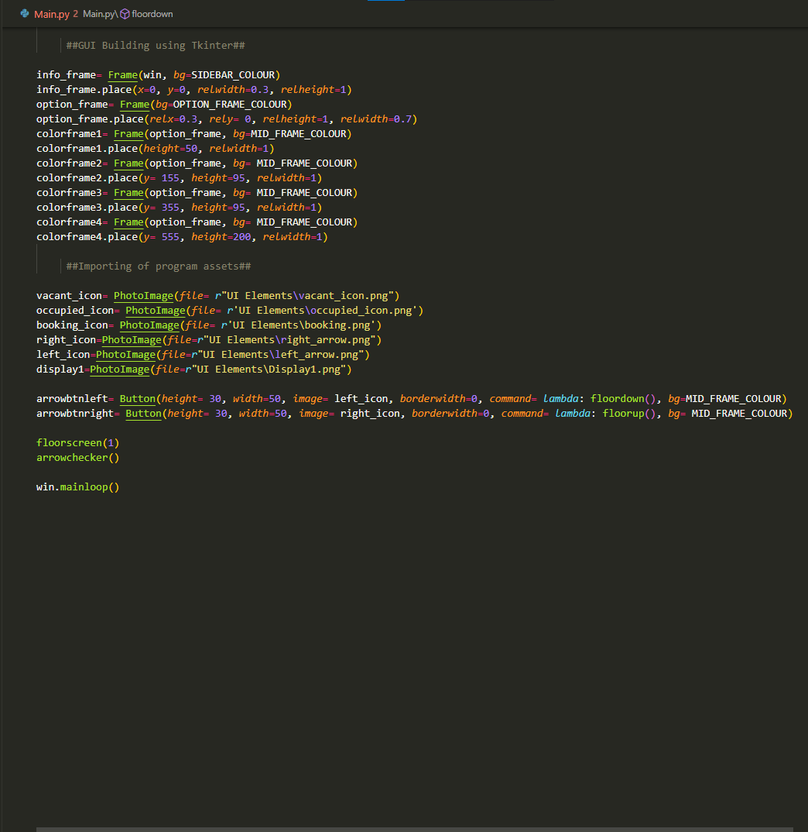

1. **constants.py**

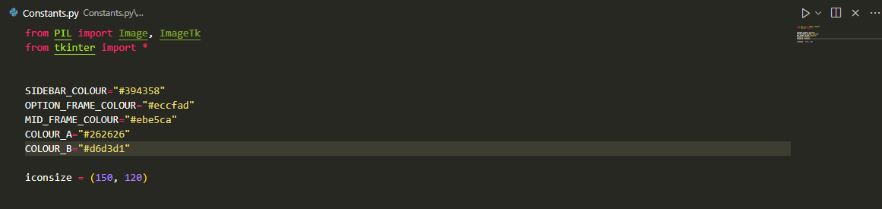

1. **db.py**

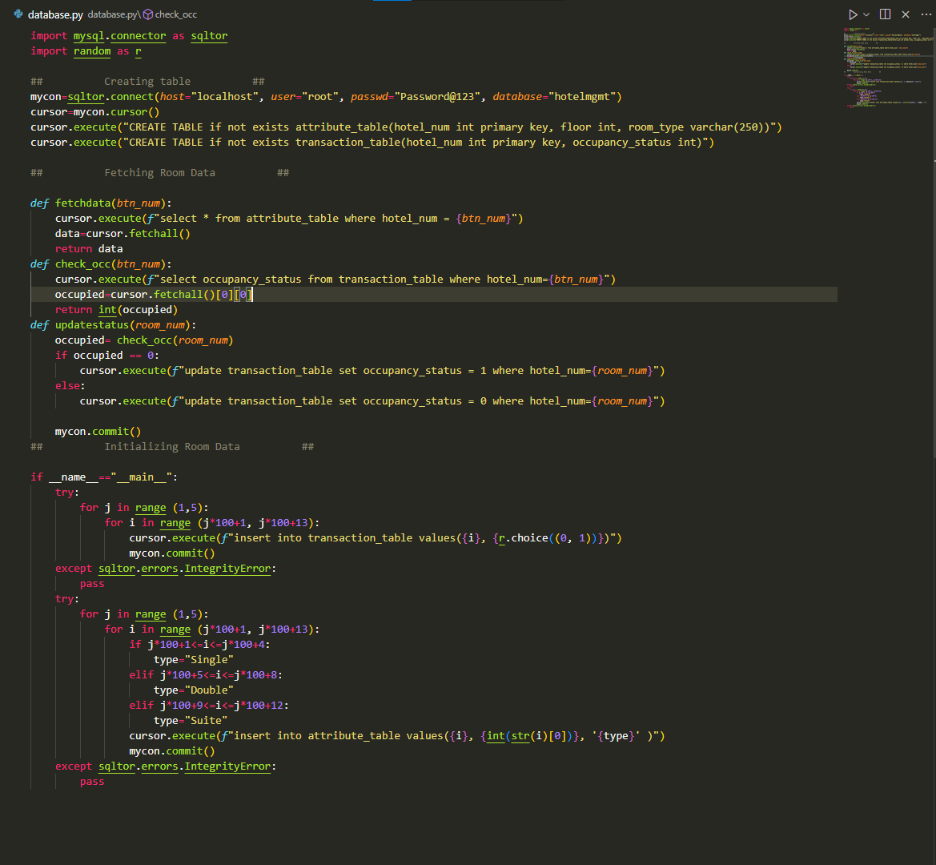

**OUTPUT**

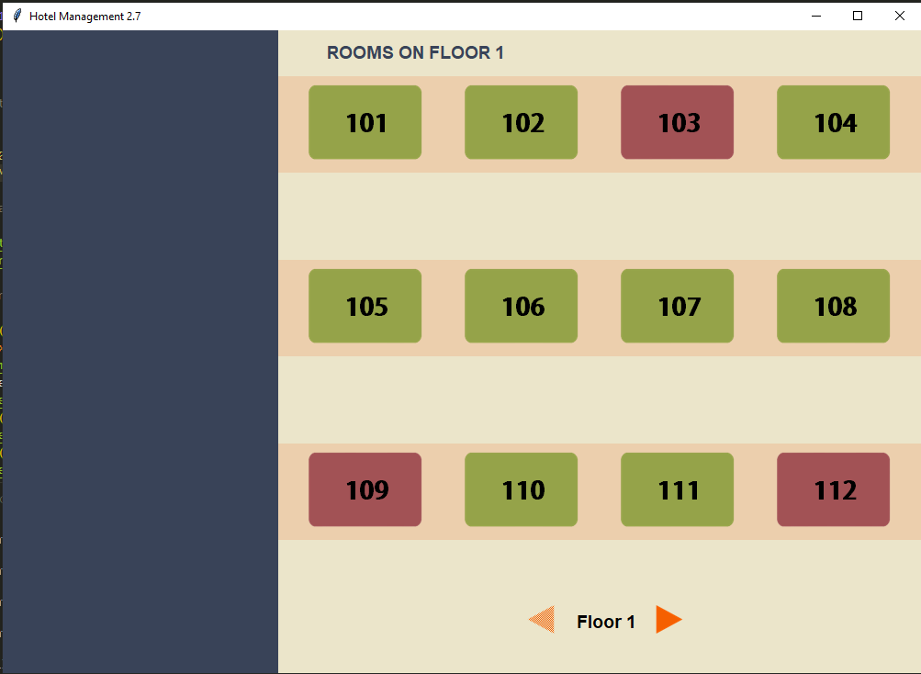

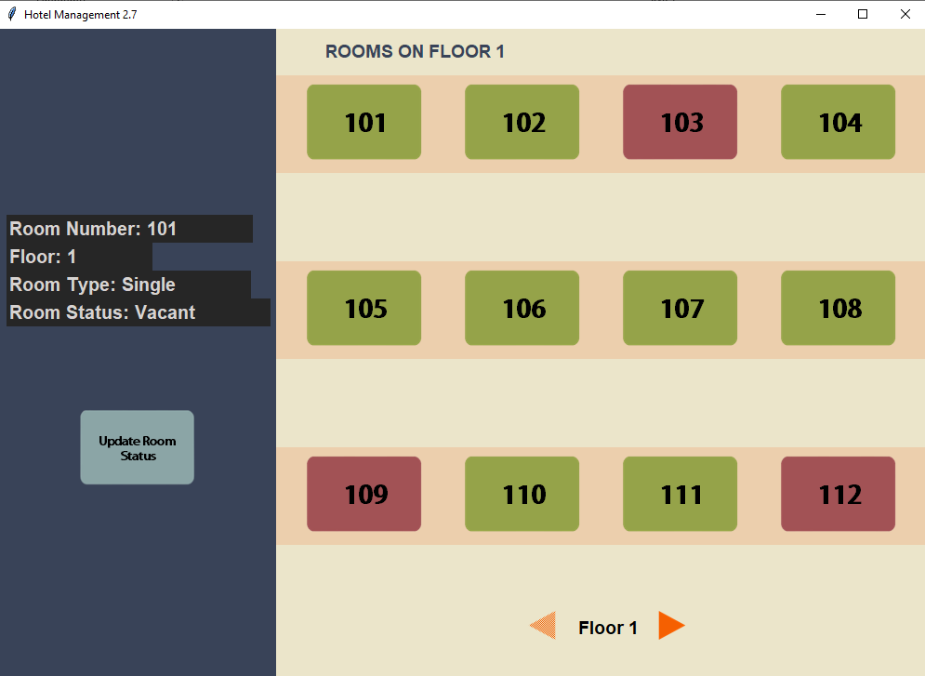

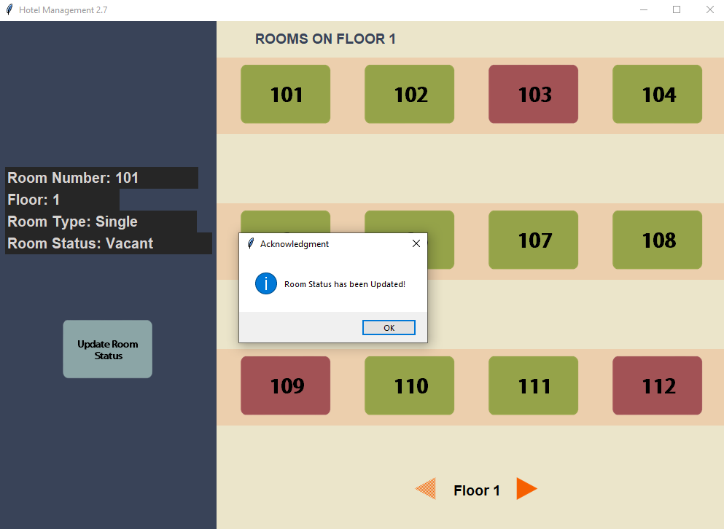

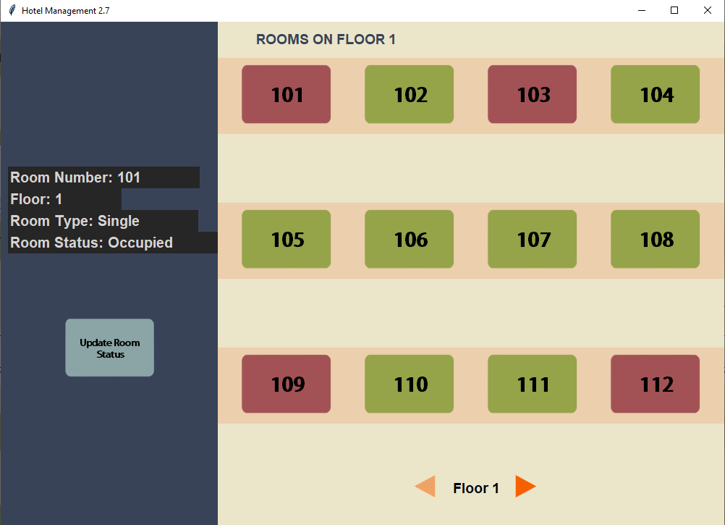

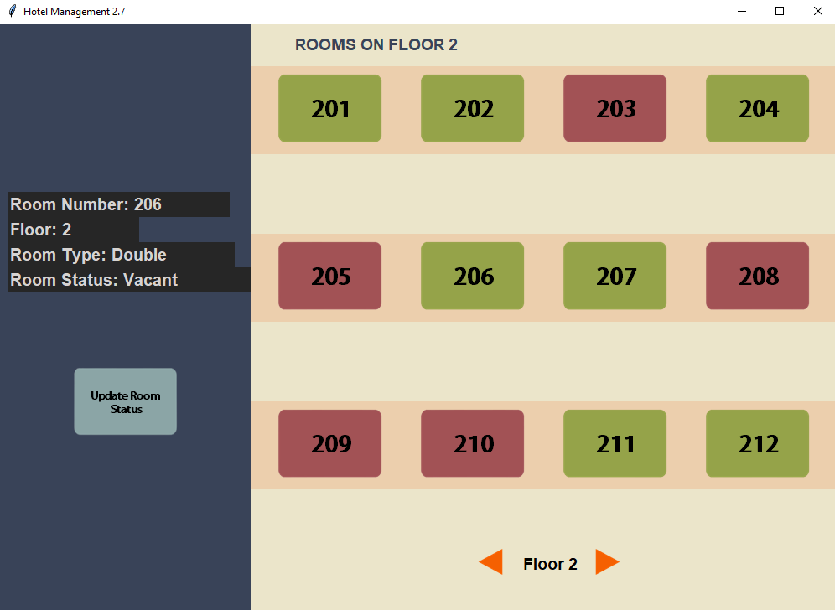

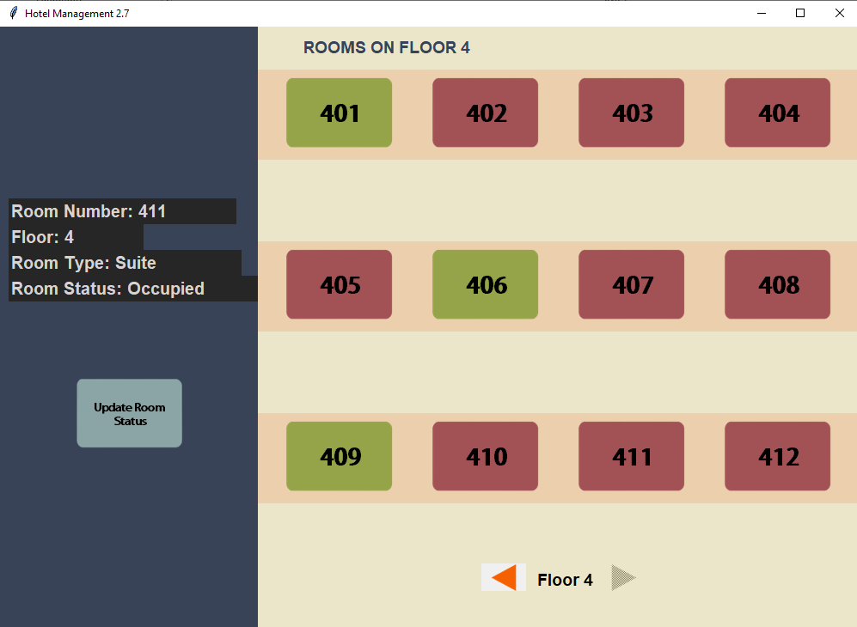

**REFERENCES**

* Google
* Computer science with Sumita Aurora